## In previous tutorial we had deployed a Spring Boot Application to PCF. Let us now look at some PCF concepts like Orgs, Spaces. We will also look at the PCF Deployment Process that occurs after cf push. PCF Orgs and Spaces

Consider we have to deploy PCF for a Bank.  
  
The first step will be to get the cloud platform from sme cloud provider like AWS or Azure. Next we will start the PCF deployment on this cloud platform.  
Suppose for a Bank there are 2 projects-

* Wealth Management
* Investment Banking

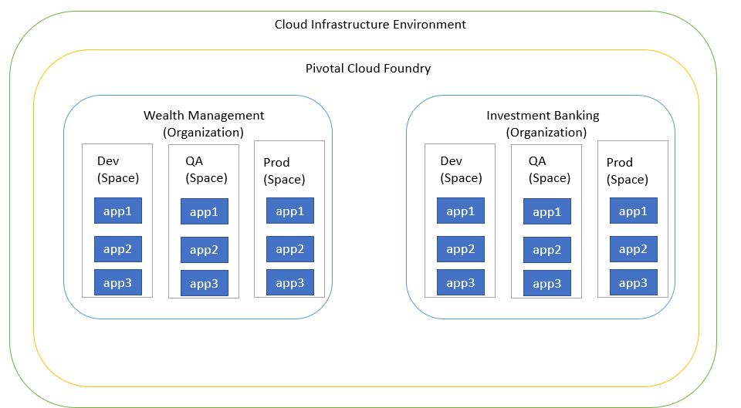

We will then create 2 orgs named Wealth Management and Investment Banking.  
  
Organization (org) is a development account that encompasses computing resources, apps, and services. It can be owned and used by an individual or by multiple collaborators.

Within the individual orgs we have the spaces.

**PCF Architecture**

Let us take a look at the PCF architecture-  
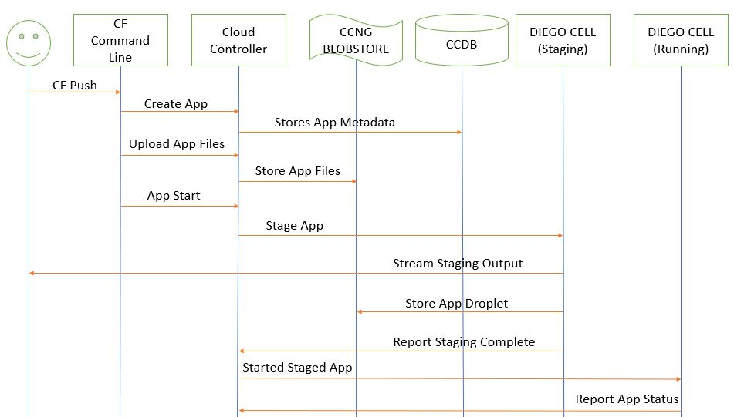  
  
**Diego** is a self-healing container management system that attempts to keep the correct number of instances running in Diego Cells to avoid network failures and crashes. Diego schedules and runs Tasks and Long-Running Processes (LRP).  
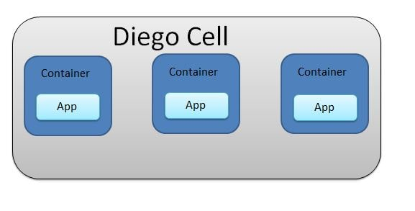

Following are the Roles and the associated permissions for PCF

|  |  |
| --- | --- |
| **Role** | **Permissions** |
| Admin | An admin user has permissions on all orgs and spaces |
| Admin Read-Only | This role has read-only access to all Cloud Controller API resources. |
| Global Auditor | This role has read-only access to all Cloud Controller API resources except for secrets such as environment variables. |
| Org Managers | managers or other users who need to administer the org |
| Org Auditors | view but cannot edit user information and org quota usage information |
| Org Billing Managers | create and manage billing account and payment information |
| Org Users | Can view the list of other org users and their roles. When an Org Manager gives a person an Org or Space role, that person automatically receives Org User status in that Org |
| Space Managers | Managers or other users who administer a space within an org |
| Space Developers | Application developers or other users who manage applications and services in a space |
| Space Auditors | View but cannot edit the space |